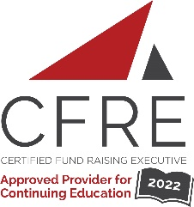
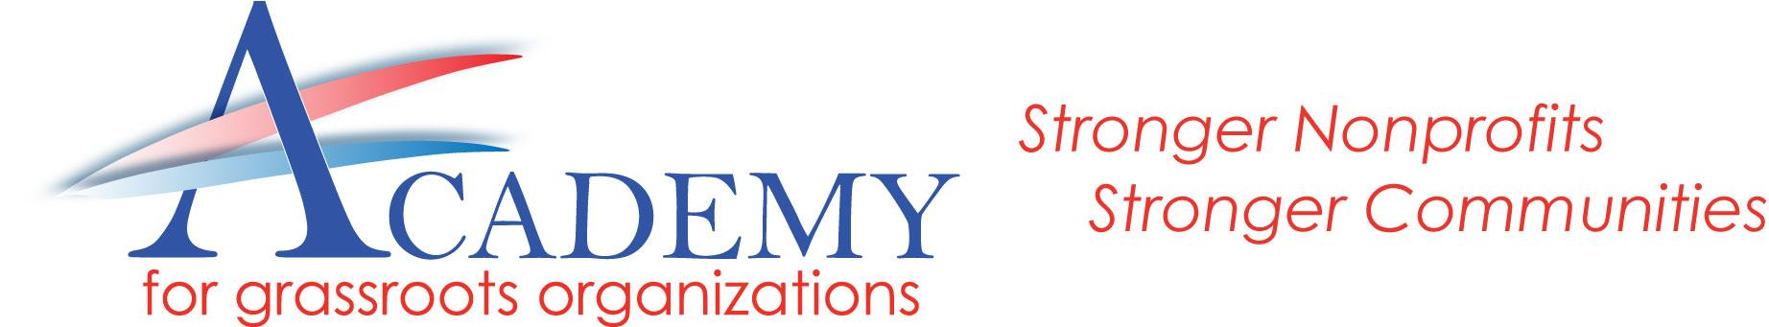

The Fundraising Academy for Grassroots OrganizationsTM

Fall Class of 2022 Application Form

We are delighted that you are interested in participating in the 2022 Fundraising Academy!

We need only a few pieces of information to process your application.
Please complete the application and send it by August 17 Admin@AcademyGO.com
We will need to know that your organization is supporting your participation: The Academy will be 5 days of trainings, plus 5 hours per month of homework assignments. Please make sure that the person you report to (board chair, your supervisor) signs your application and understands the time and financial commitments.

Applications are due by August 17, 2022, however the sooner you submit yours the better.
There is space for only 25 in the class.
We will review all applications and notify you within 48 hours of receiving application.

Course Schedule: The first day of The Academy will be August 26. Additional course dates will be: Sept, 2 ,9, 16 & 23. Please hold these dates until your application is processed and you are notified about acceptance.
Special Rate: Special rates are made possible through the generosity of the AcademyGO Leadership Circle Donors.

Cost per person is $475* per attendee ($2,200 value)
*As a benefit of membership, AcademyGO members will receive an additional 20% discount.

Upon application approval, a $150 deposit will be required to hold your seat.
FULL Payment will be due no later than August 24, 2022.

For more information contact Admin@AcademyGO.com
For Information
www.TheFundraisingAcademy.com
THE FUNDRAISING ACADEMY
for Grassroots OrganizationsTM

Fall Class of 2022 Application Form

Please complete the following information. ALL fields MUST be completed. DO NOT MODIFY FORM.
Make a copy for your records and send the completed form to: Admin@AcademyGO.com
by August 17, 2022.

Name: _______________________________ Title: ______________________________

Work Phone: __________________________ Cell Phone: __________________________

Organization: ____________________________________________________

Organization Mailing Address: _____________________________________________________________

E-Mail Address: ________________________________________ Web Address: _____________________

Our organization serves Inland Empire residents. ❒ Yes ❒ No
Our organization is a 501(C) (3) ❒ Yes ❒ No
How many years have you been involved with nonprofits? __________________

Our organization serves low to moderate income persons. ❒ Yes ❒ No

Our annual Budget (expenses) for the most recently completed fiscal year was $_______________

Our organization is a current Member of AcademyGO. ❒ Yes ❒ No

Please state how your participation in The Fundraising Academy will benefit your organization
AND the community. 250 Word Limit.

THE FUNDRAISING ACADEMY
for Grassroots OrganizationsTM

I am the applicant’s supervisor and I approve of this application. I will support this applicant’s learning by allowing them to attend the course during work time. I understand that if accepted, the full payment must be paid by August 24, 2022.

______________________________ ___________________________ ____________________
Signature - Board Chair or Supervisor Printed Name Date

I am able and agree to commit the time necessary to complete this course. (5 class days, plus 5 hours per month for homework assignments.)

__________________________________ _____________________
Signature of Applicant Date

