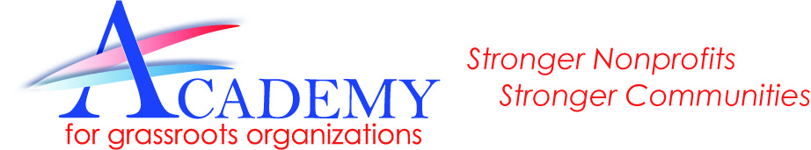

The Grantwriting Academy for Grassroots Organizations™
March 24, 31, April 7 & 14, 2023

Application

We are delighted that you are interested in participating in the upcoming Grantwriting Academy!

We need only a few pieces of information to process your Application. Please complete the reverse side of this form and send it by March 10, 2023, to Paula Martinez at Admin@AcademyGO.com

We will need to know that your organization is supporting your participation: The Grantwriting Academy will include 4 full days of training and homework assignments. Please make sure that the person you report to (board chair, your supervisor) signs your application and understands the time and financial commitments. Attendance at all 4 full-day sessions is a mandatory requirement.

Applications are due by March 10, 2023; however, the sooner you submit yours, the better. Space is limited! We will review all applications and notify you by email if your application has been accepted.

Course Schedule: March 24, 31, April 7, 14, 2023. Please hold these dates until your application is processed and you are notified about acceptance. Time: 9:00 a.m. – 4:00 p.m.

Course Overview:

Learn essential grant development skills.

Explore funding opportunities and proven research techniques.

Spend time developing your own individualized grant template.

Received feedback to help optimize your success.

Location: San Bernardino County Superintendent of Schools

West End Educational Service Center

8265 Aspen Street

Rancho Cucamonga, CA 91730

Costs: Selected Applicants will pay only a modest Tuition fee of $375* (a $750 value) per person.

*AcademyGO Members receive an additional 20% discount.

Special rates are made possible through the generosity of AcademyGO Leadership Circle Donors.

Full Payment must be received by March 22, 2023.
For More Information:
Email: Admin@AcademyGO.com

For Information

www.TheFundraisingAcademy.com

The Grantwriting Academy for Grassroots Organizations™

Application Form

Course Schedule: March 24, 31, April 7, 14, 2023. Please hold these dates until your application is processed and you are notified about acceptance. Time: 9:00 a.m. – 4:00 p.m.

Please complete the following information. ALL fields MUST be completed. DO NOT MODIFY FORM.
Make a copy for your records and send the completed form to Admin@AcademyGO.com by March 10, 2023.

Name: ______________________ Telephone: ____________________

Organization: ____________________________________________________

Organization Mailing Address: _______________________________________________________________

E-Mail Address: _________________________________________

Our organization serves San Bernardino and/or Riverside County residents.  Yes  No

Our organization serves low to moderate-income persons.  Yes  No

Our annual Budget (expenses) for the most recently completed fiscal year was $____________.

Our organization is a current Member of AcademyGO.  Yes  No

Please state how your participation in The Grantwriting Academy for Grassroots Organizations™ will
benefit your organization AND the community.

I am the applicant’s supervisor and I approve of this application. I will support this applicant’s learning by allowing them to attend the course during work time. I understand that if accepted, a Tuition of $375* (see reverse) will be due by March 22, 2023. *AcademyGO Members receive an additional 20% discount.

______________________________ ___________________________ ____________________
Signature - Board Chair or Supervisor Printed Name Date

I can and agree to commit the time necessary to complete this course. (4 class days, plus approximately 8 hours for homework assignments). Attendance at all 4 full-day sessions is a mandatory requirement.

__________________________________ _____________________
Signature of Applicant Date

If you do not receive a confirmation email within 48 hours of submission
please send an email to Admin@AcademyGO.com

